Carter Shields

DS 3002 Lab 2

1. What types of information does Firefox manage using SQLite? Briefly explain the contents of two or three databases.

The places database manages different information about the user’s preferences with Firefox. This includes keywords, bookmarks, and history visits. The data includes date added, date modified, the ID, and position of the data.

2. In what database and tables are your bookmarks stored? Why do you think

Firefox stores the title and url separately?

Bookmarks are stored in the places database and in the moz_bookmarks table. Firefox stores the title and url separately because you can edit the title to be whatever you want it to be, but the url is universal. The url’s and titles are stored in moz_places together, but the titles are also stored by themselves in moz_bookmarks.

3. Write an SQL statement that selects your bookmarks. For each one, display

only the title, url, date added (as an integer), and visit count.

SELECT moz_places.title, moz_places.url, moz_bookmarks.dateAdded, moz_places.visit_count

FROM moz_places, moz_bookmarks

WHERE moz_places.title = moz_bookmarks.title

4. Write an SQL statement that lists the base domain, name, and value for each

of your cookies in order of expiration date.

SELECT moz_cookies.host, moz_cookies.name, moz_cookies.value

FROM moz_cookies

ORDER BY expiry DESC

5. Write an SQL statement to show how many cookies you have for each domain.

Note that you will need to use the "count" function instead of sum.

SELECT moz_cookies.host, count(moz_cookies.host)

FROM moz_cookies

GROUP BY host

6. What are the top five movies since the year 2000, in terms of adjusted

gross income?

SELECT movie.title

FROM movie

WHERE year >= 2000

ORDER BY adjusted DESC LIMIT 5

7. What are the title, author, and year of books from Russia in the top 100?

(For convenience, you can right-click the results and "Copy Rows as CSV.")

SELECT title, author, year

FROM book

WHERE country = "Russia"

8. What are the names and symbols of the periodic elements with an atomic mass

of more than 280? Display the results from lightest to heaviest.

SELECT name, symbol

FROM periodic

WHERE mass > 280

ORDER BY mass ASC

9. Which of the top 15 songs were featured in the top 100 movies? (Hint: Figure

out how to join the two tables, and then use AND clauses to filter by rank.)

SELECT *

FROM song

INNER JOIN movie ON song.title = movie.title

WHERE song.rank <= 15

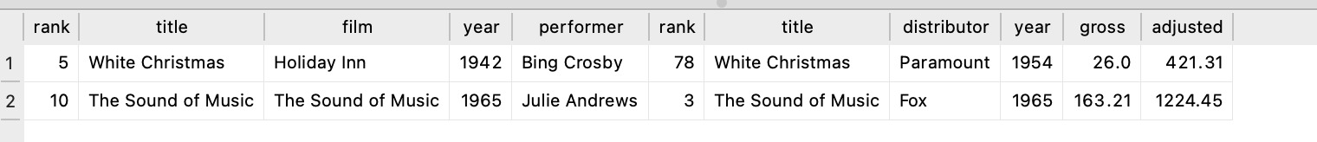

10. Do you Python Lab

**Used under the open commons from JMU CS101 Labs